**Static Routing with Connecting 4 Routers**

**STEP-01 Design Topology**

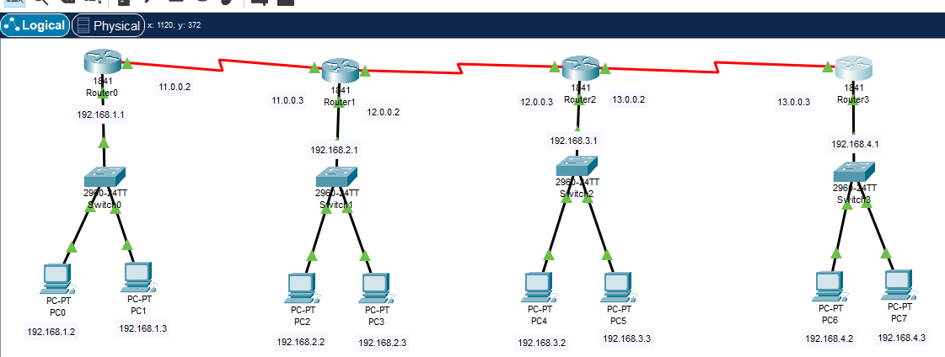

**STEP-02 Set Networks/ Add Static Routes on Router 0, Router 1, Router 2 and Router 3**

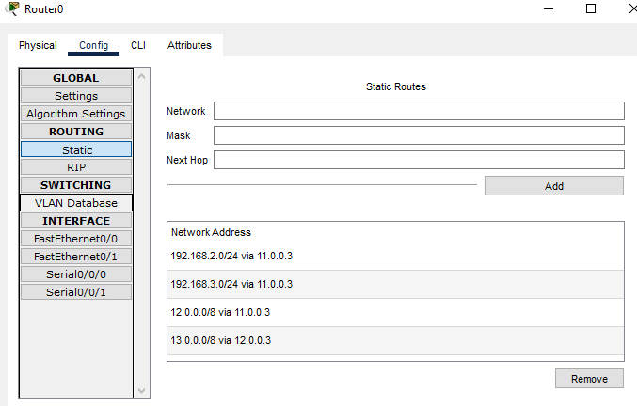

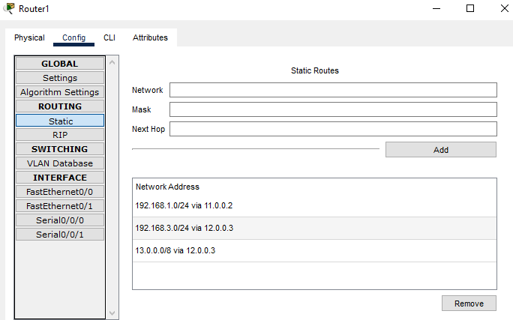

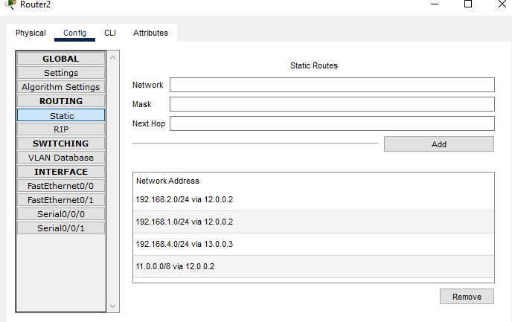

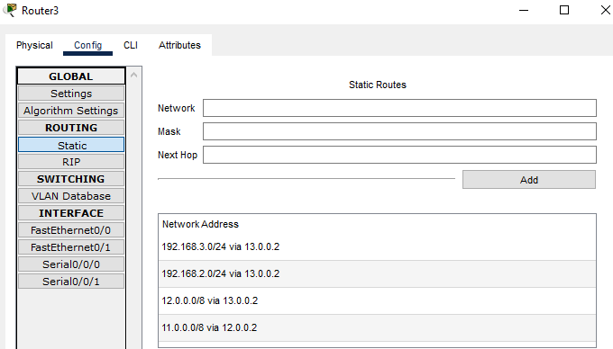

# Dynamic routing RIP version 1 (Routing information protocol)

**STEP-01 Design Topology**

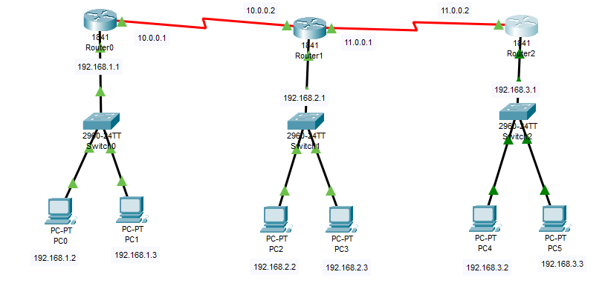

**STEP-02 Set Networks/ Add Dynamic Routes (RIP) on Router 0, Router 1, and Router 2**

